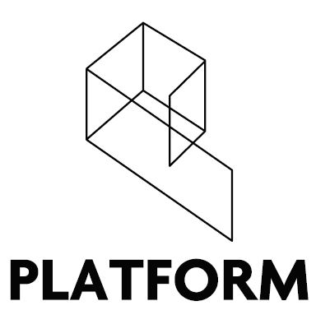

Director Specification 2020

Location: Connswater Shopping Centre, 17-18 Bloomfield Ave, Belfast BT5 5LP
Duration: 2 years
Salary: N/A – Voluntary (Expenses will be covered)

Experience:
New Directors bring fresh ideas and energy which are vital to ensuring the continued development of Platform as a vibrant artist-led organisation. Previous experience is desirable but not essential as full training will be given. The most important requirement for a Director is a willingness to be involved and an enthusiasm for the objectives of Platform.

Working Arrangements:
Applicants should be prepared to commit on average 4-8 hours per week depending on our calendar of events. This will not necessarily be during traditional working hours and work can be completed remotely. Working arrangements are flexible depending on individual availability and role within the Board. Attendance at monthly Board meetings in Belfast is mandatory. Directors should also be able to commit to attending exhibition openings and other programmed events. Each Director must take an active role in gallery invigilation as well as attending committee meetings as and when required.

Personal Specification:
- An appreciation, enthusiasm and commitment to the objectives of Platform Arts.
- Practical and resourceful with the ability to achieve set targets and objectives.
- Knowledge of the local and international contemporary art scene.
- A drive to develop Platform Arts through programming, outreach, creative projects and professional development opportunities.
- Self-motivated able to use own initiative with excellent organisational and time management skills.
- Ability to work productively as part of a small team.

To Apply:
To apply please send a completed Platform Arts Director Application Form to platformbelfast@gmail.com before the deadline of 9pm, Monday 5th October 2020.

Please feel free to email us with any queries.

