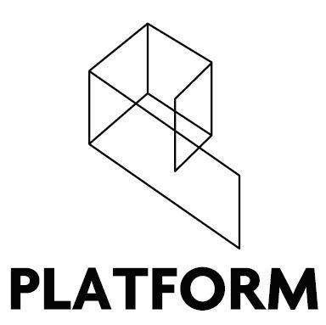

Platform Arts
Director Application Form 2021

Deadline for applications: 5pm, Wednesday 25th August 2021.

Personal Details
Name
Email
Phone
Address

Education
Add as many additional rows as needed.
Institution / Awarding Body | Subject | Grade | Date Awarded

Employment History
Please give details of positions held including relevant part-time and unpaid work, starting with your current or most recent employer. Add as many additional rows as needed.
Date |  | Employer Name & Address | Position Held & Responsibilities
From | To

Why do you want to be a Director at Platform Arts? (Max. 300 words)

With reference to the Director Specification, please outline how your skills and experience make you a suitable candidate for Directorship with Platform Arts.
(Max. 500 words)

References
Please complete the details below for two people that we may contact for a reference. These persons should be unrelated to you, and where possible one must be your current or most recent employer.
Name |  | Name
Phone |  | Phone
Email |  | Email
Address |  | Address
Occupation |  | Occupation
Relationship to you |  | Relationship to you

Declaration
I declare that the information I have provided in this application form is, to the best of my knowledge and belief, correct and complete.

Signed: _____________________ Date: _____________

Please return completed application forms to platformbelfast@gmail.com before the deadline of 5pm Monday 23rd August 2021.

