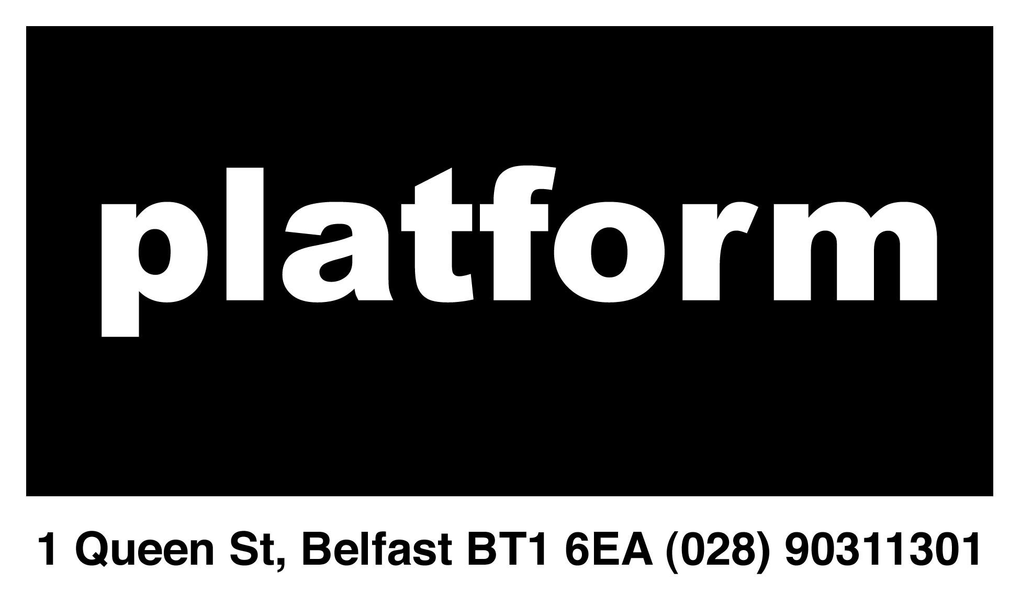

BELFAST PLATFORM FOR THE ARTS
DIRECTORS APPLICATION FORM

Please read the Directors specifications before filling out your application

Application Form:

Please complete in full using a word package. Applicants most be aged 18 years and over

Please send a PDF version of your completed form, including a copy of your C.V. (max. 2 pages), to platformbelfast@gmail.com, with the subject line Platform Arts Directors.

Deadline 6pm, 4th August 2014

Name:
Mobile:
Email:
Area(s) of Interest:

Please tell us, in 300 words or less, why you would like to be a Director with Platform.

Please outline for us, in 800 words or less, your previous experience and how you feel it will help you in the role of a director with Platform.

Please give contact details for two personal references (at least one professional) that can comment on your ability to carry out the duties for which you have applied.

