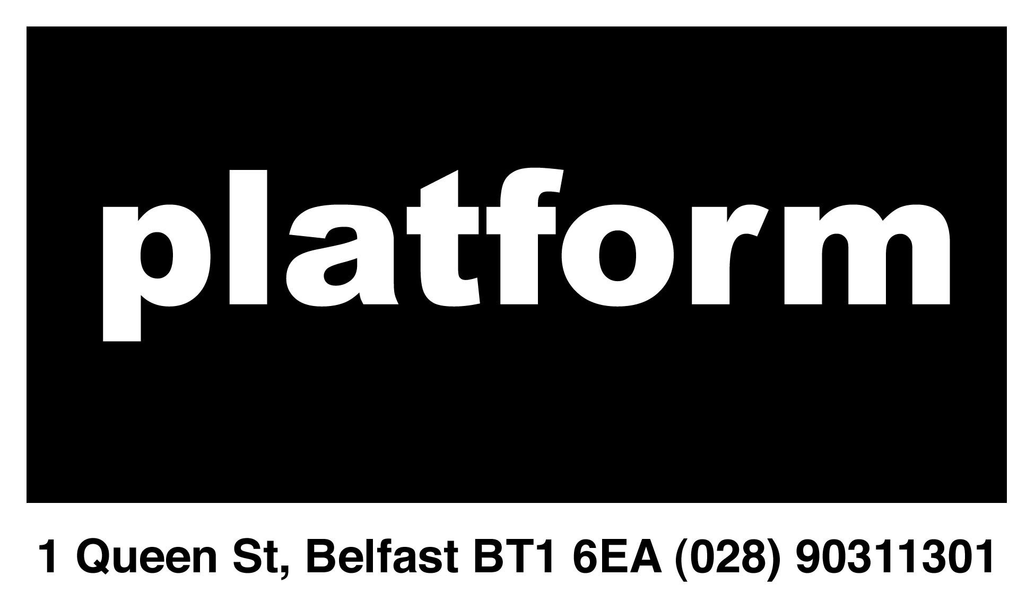

Platform Arts Director Specification 2014

Platform Arts is currently seeking directors with a particular interest in, but not limited to,

- Funding for the arts
- Administration and Finance
- General Management

Previous experience is desirable, but not essential, as the current directors will mentor the new members of the Board.

Directors are placed into working groups of several people. The groups specialize in areas such as funding, gallery management, administration, finance, outreach and publicity, etc. All directors are involved in the programming of the galleries, with each exhibitor/event project managed by one of the directors. Directors are also expected to help (when necessary) with the general running of the organization.

Platform is looking for motivated individuals to join the Board who work well both independently and as part of a team. They should have a desire to learn about the running of an arts organization and to gain, expand or transfer relevant knowledge and skills in this area.

Please note: the role of Co-Director entails a serious time commitment. Whilst it is voluntary, the role can demand a significant amount of your time every week. It is our experience that Directors should be willing and able to dedicate the equivalent of two days per week (not necessarily traditional working days) to meet the basic demands and expectations of the role.

2.1 Roles

2.1.1 Funding for the Arts

Funding is becoming an important part of Platforms Arts’ programs. A director with an interest in this area would be expected:

- To actively seek out funding opportunities
- To fill out funding applications
- To attend meetings / seminars with funding bodies in regards to their funding programs
- To seek out and help secure funding for gallery shows, if required
- To keep good and accurate records of all funding applications and their outcomes
- To advise the Board and members on funding for their shows, projects and events
- To help the other Directors in their own roles
- To attend Board meetings

2.1.2 Finance and Administration

Platform Arts’ requires directors to work within the finance, governance and administration working group. Such duties would include:

- The management and administration of a small business account
- Keeping track of incoming and outgoing finances
- The drawing up of budgets and cash flow projections
- The filing and management of documents and records
- Attendance of Board meetings

2.1.3 General Management

Platform is also looking for motivated general Directors, who work well both independently and within a team environment, but who may not yet have a defined area of interest. A potential director for this role would want to learn about and try out the different roles involved with the running of an arts organization before potentially specialising. A general Director would be expected to:

- Be involved in the day-to-day running and management of the gallery and studio
- Consult with the other Directors in decisions regarding Platform’s long-term strategy
- Work with the other Directors as a support for their own specialized roles
- To help with the writing of various applications
- Research the polices and procedures of the organization and be able to advise the Board and Members on them
- Research, write and update handbooks, polices and procedures and funding applications in conjunction with the Board and the members as required
- To attend Board meetings

If you are interested in applying for a Directorship at Platform please fill out the application form. We look forward to hearing from you.

