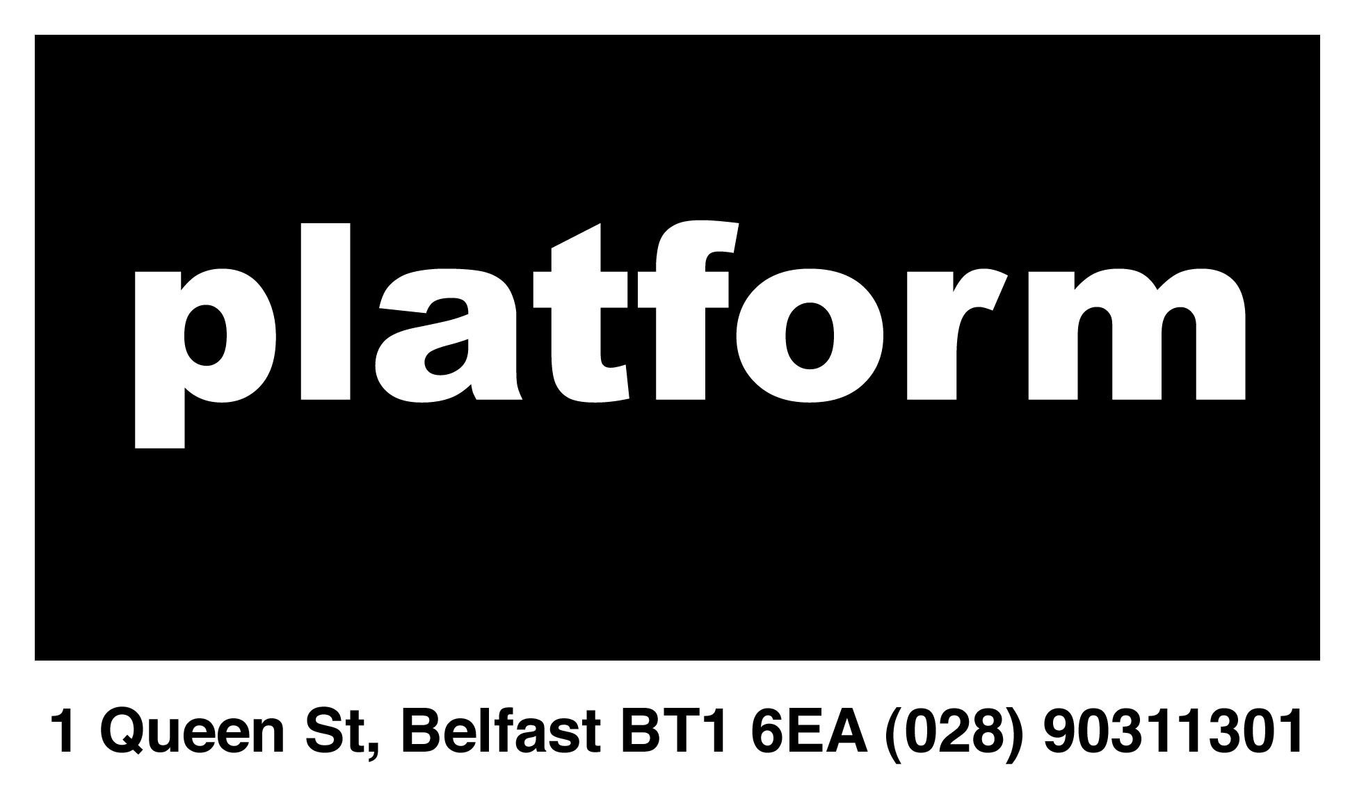

EQUALITY MONITORING
Private and Confidential

Belfast Platform for the Arts is committed to equality of opportunity. It considers that monitoring is essential to the effective implementation of this. We would therefore ask you to complete this form.

This form is solely for the purpose of equality monitoring. It will not have any effect on your application or membership of Platform.

Please complete this questionnaire and return by a separate email with the subject line Platform Equality Monitoring

Date of birth: ________________________

Gender: ________________________

Marital status: ________________________

Nationality: (as stated on your passport) _______________________

Ethnic origin:

Caucasian: ___ Asian: ___ Black: ___ Irish Traveler: ___

Other or mixed ethnic group (please state): ________________________

Disability

The Disability Discrimination Act 1995 defines a disabled person as someone with a physical or mental impairment, which has a substantive and long-term adverse effect on his/her ability to carry out normal day-to-day activities.

Having read this definition do you consider that you are a disabled person or that you have a disability?

Y/N ________

If you answered yes please state the nature or effects of your disability:

________________________________________________________________

________________________________________________________________

Community Background

To demonstrate our commitment to equality of opportunity in employment we need to monitor the community background of applicants and employees, as required by the Fair Employment and Treatment (NI) Order 1998. Regardless of whether we practice religion, most of us in Northern Ireland are seen as either Roman Catholic or Protestant.

Please indicate your community background

- I have a Roman Catholic community background ___
- I have a Protestant community background ___
- I have neither a Roman Catholic nor a Protestant community background ___

If you do not complete this section we are encouraged to use the ‘residuary method’ of monitoring, which means that we can make a determination on the basis of personal information on file or your application form.

Religious Belief

In support of Section 75 of the Northern Ireland Act 1998, Platform monitors the religious belief of applicants and employees. We recognise that there may be occasions where religious belief differs to perceived community background, especially where the residuary method has been used to make a determination.

Please indicate your religious belief: _Non practicing catholic _________________________________

If 'Other', please specify: __________________________________________

Dependants:

We understand persons with dependants to be those with personal responsibility for the care of a child, the care of a person with an incapacitating disability and/or the care of a dependant elderly person.

Do you have dependants? Y/N ___

Sexual Orientation

Heterosexual ___
Gay / Lesbian ___
Bisexual ___
Decline to answer ___

