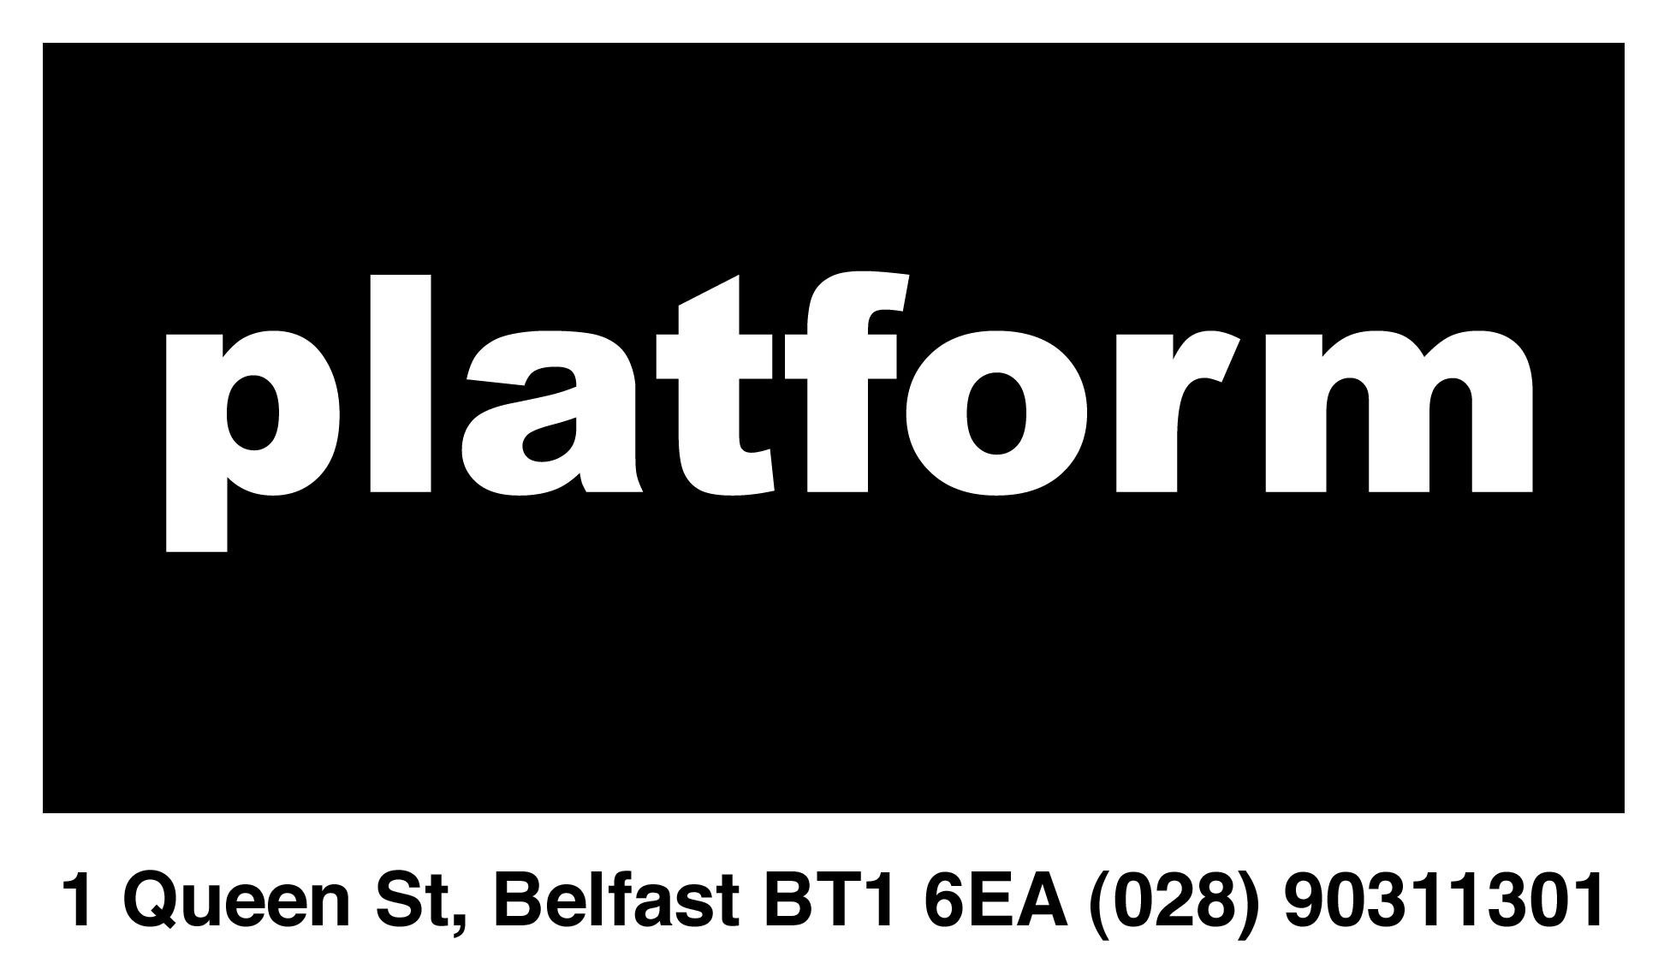

BELFAST PLATFORM FOR THE ARTS
MAIN GALLERY PROPOSAL FORM

Deadline: 6pm, 31st October 2013

Please fill out all sections of this form and save as a .PDF. Then email to platformbelfast@gmail.com. Please include “MG Proposal: <Your Name>” in the subject line of the email.

CV (max 2 pages) containing the following contact details: name, address, email, phone, website (if available)

Artist Statement (Max 500 words)

Proposal summary:

Please provide a short summary of the exhibition, installation or event you wish to propose (max 800 words). This should cover the main themes of the work and an idea of how you propose to install it within the space. Please see the guidelines for a plan of the main gallery. Please attach any pictures or videos as per the guidelines.

Supporting images/links

Funding

Please provide details on how you plan to fund your exhibition, installation or event. Funding does not need to have been secured but a reasonable plan and backup plan for how you intend to fund, and / or how Platform can help you with your funding, is required.

Further Information:

Please provide any further information (max 800 words) that you feel is relevant to your proposal.

