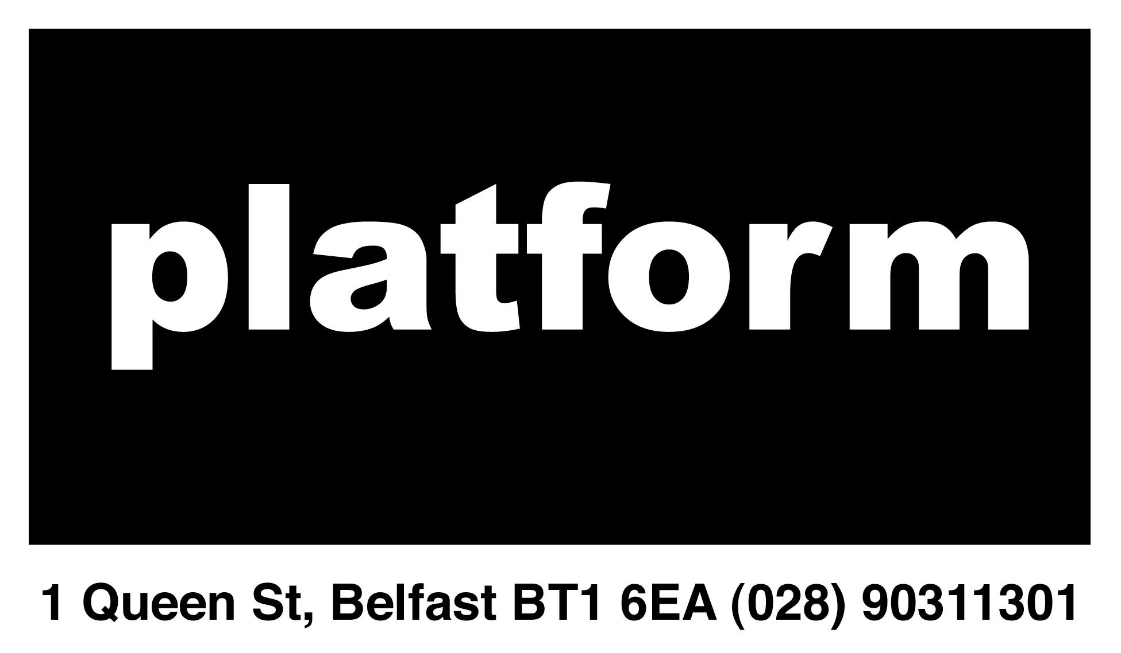

**BELFAST PLATFORM FOR THE ARTS**

# VOLUNTEER APPLICATION FORM

**Outline:**

Platform Arts is an artist led studio group and gallery in Belfast’s City Centre. We are looking for enthusiastic volunteers to help with installing shows, invigilating the gallery and more.

**Application Form:**

Please complete in full. Applicants must be aged 18 years and over.

**Name:** _______________________________________________

**Mobile**: _______________________________________________

**Email:** _______________________________________________

**Address:** _____________________________________________

**Postcode:** ____________________________________________

**Areas of Interest:**

Installation



Invigilation



Outreach



Administration



Event / Opening Nights



Marketing



Web / Social Media



Design



**Availability (Please Note):**

**Please give contact details for two personal references (at least one professional) that can comment on your ability to carry out the duties for which you have applied.**

**Declaration**

The information provided is true to the best of knowledge. If offered a position as a volunteer at Belfast Platform for the Arts I agree to abide by the code of conduct and the rules and regulations of Platform.

**Signature:** ________________________________ **Date:** _______________