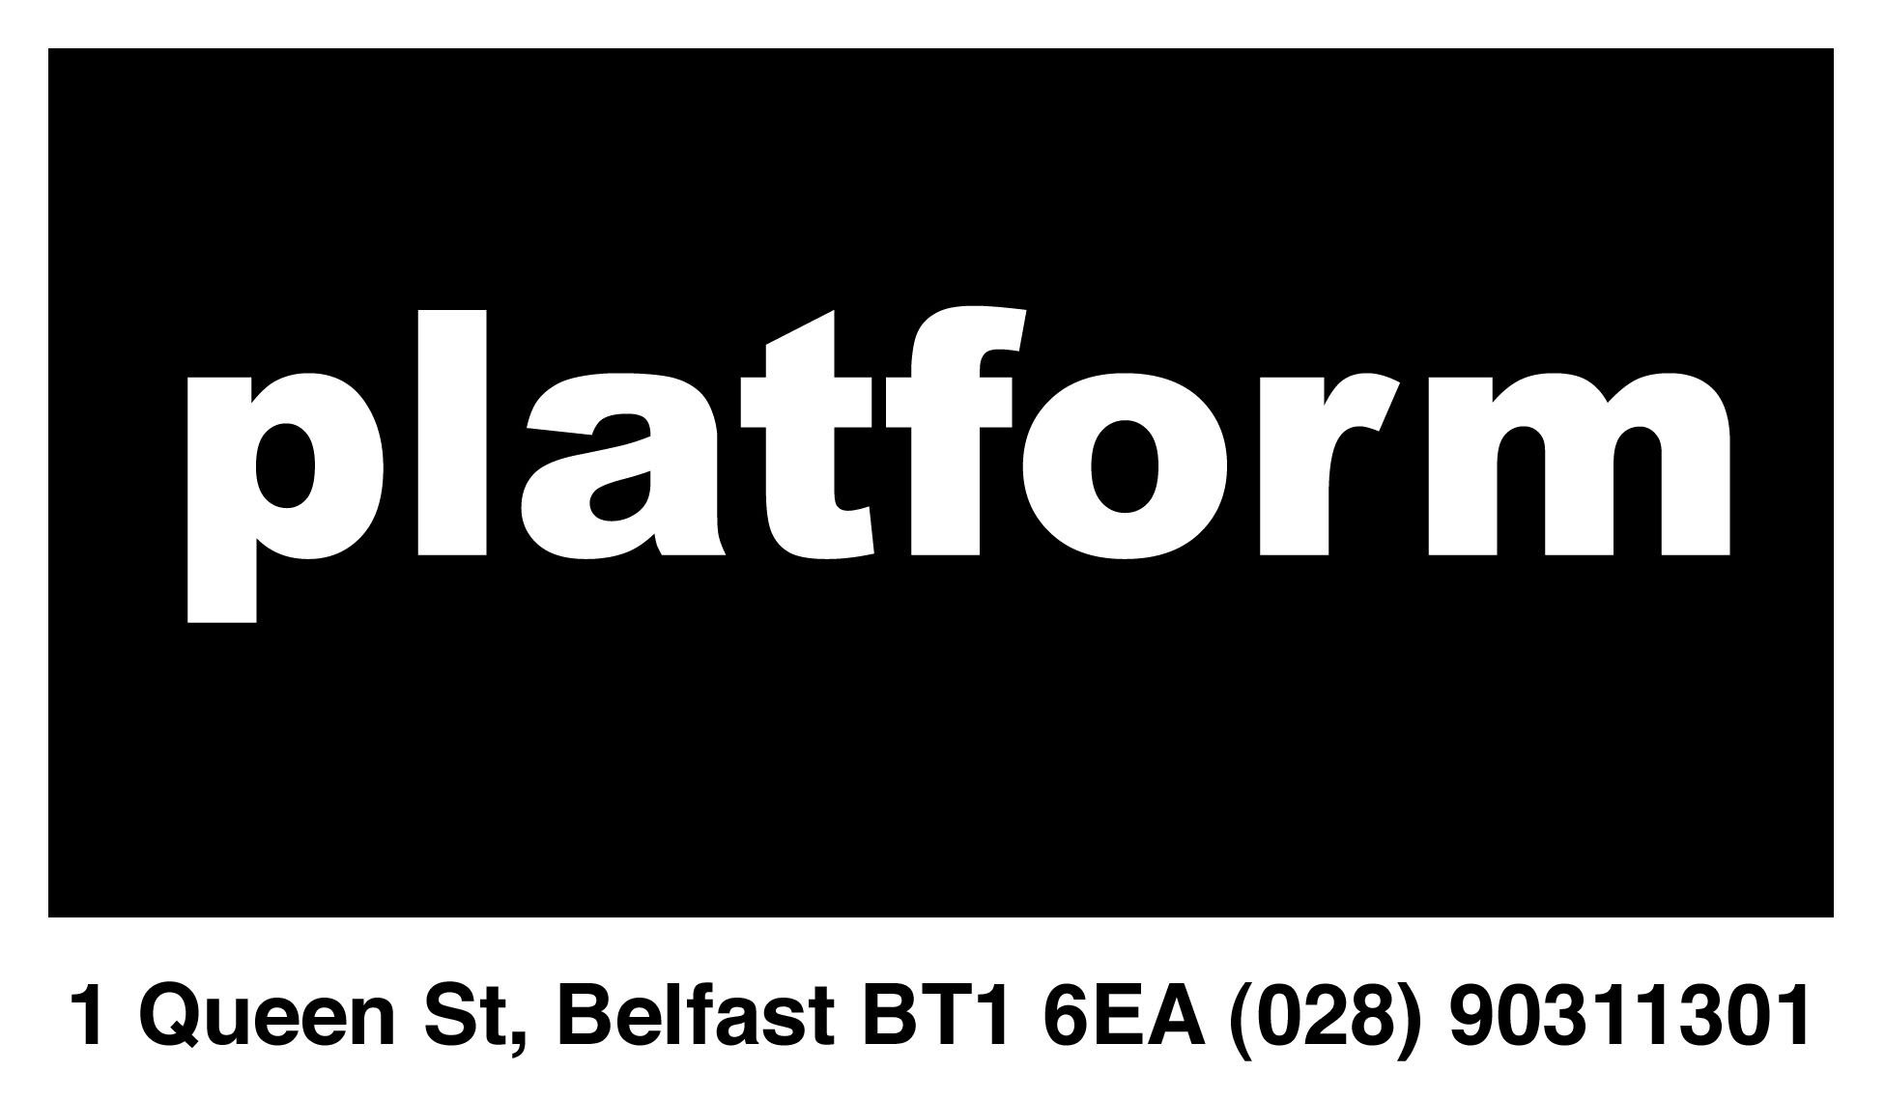

STUDIO FOR RENT

The Studio:

This is a great opportunity for an artist looking to rent a well-maintained studio in a central Belfast location as part of a young dynamic art collective.

Studio 009 is 14.7sq meters or 48sq feet in size. It is a roomy, naturally lit space, suiting a variety of uses. It rents for £75 a month and will be available from the 1st of November 2014.

How to Apply:

Expressions of interest should be sent to platformbelfast@gmail.com, titled Expressions of Interest Studios and should include;

- Current CV
- Short artist statement including any relevant websites or video links
- Up to six images of recent work in jpeg format no bigger then 1000 px length at 72dpi.

Deadlines:

Studio 009 deadline for applications - 10am Monday 27th Oct.

About Platform:

Platform is an artist-led studio and gallery group in Belfast’s city centre. Our role is to actively promote creation, presentation and access to contemporary art practice through our Exhibition, Education and Studio Programmes.

Platform provides affordable studio space to artists committed to contemporary art practice and the production of high quality artworks of all media. Studio members have 24-hour access to the building, the provision of electricity and access to WC. As an artist led initiative Platform requires a pro-active input from its studio members.

platform
1 Queen St, Belfast, BT1 6EA | 028 90311301 | www.platformartsbelfast.com | platformbelfast@gmail.com

Belfast Platform for the Arts (Platform), a company limited by guarantee.
A Charity registered in Northern Ireland, with its Registered office at 1 Queen Street, Belfast, Co Antrim, BT1 6EA.
Company Registration number: NI072553 | Charity Reg Number XT17713

